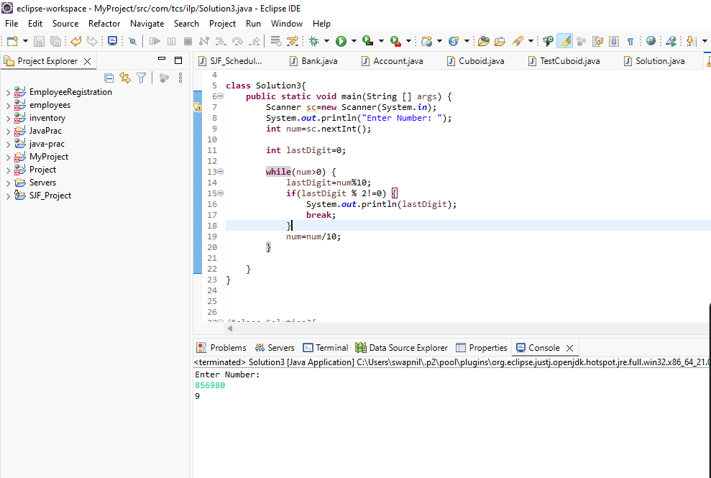

import java.util.*;

class Main{
public static void main(String [] args) {
Scanner sc=new Scanner(System.in);
System.out.println("Enter Number: ");
int num=sc.nextInt();

int lastDigit=0;

while(num>0) {
lastDigit=num%10;
if(lastDigit % 2!=0) {
System.out.println(lastDigit);
break;
}
num=num/10;
}

}
}

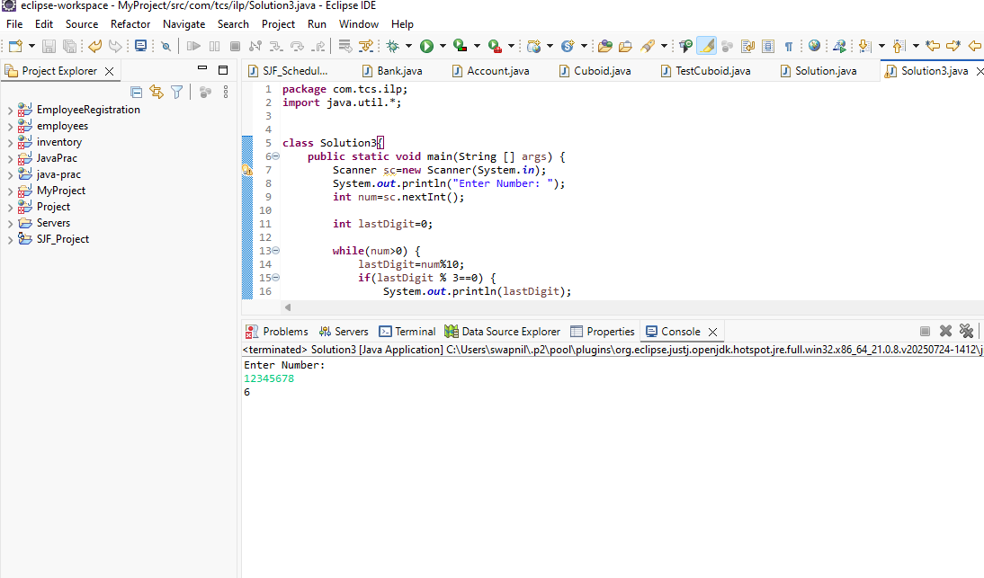

class Solution3{
public static void main(String [] args) {
Scanner sc=new Scanner(System.in);
System.out.println("Enter Number: ");
int num=sc.nextInt();

int lastDigit=0;

while(num>0) {
lastDigit=num%10;
if(lastDigit % 3==0) {
System.out.println(lastDigit);
break;
}
num=num/10;
}

}
}

